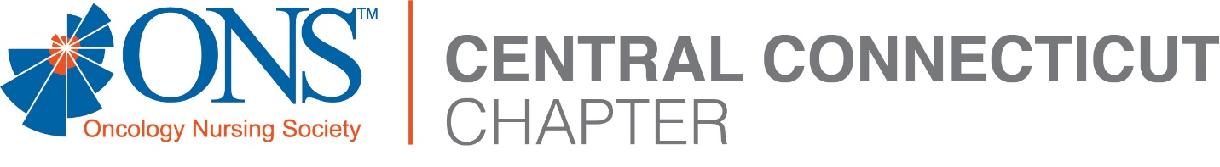

2023 OCN Review Course
Friday June 23rd, 2023 - 8:00-16:30 EST
Zoom

08:00 – 09:15 Symptom Management – Kristi Dubey, APRN

09:15 – 10:15 The Basics of Cancer – Hayley Dunnack Yackel, PhD, RN, CMSRN, OCN

10:15 – 10:20 Break

10:20 – 11:20 Cancer Treatment Modalities – Kris LeFebvre, DNP, RN, NPD-BC, AOCN

11:20 – 12:00 Lunch Break

12:00 – 13:00 Survivorship and End of Life Care – Mary Kate Eanniello, DNP, RN, OCN

13:00 – 14:30 Oncologic Emergencies – Holly DeFeo, MSN, RN, OCN, NPD-BC

14:30 – 14:45 Break

14:45 – 15:45 Professional Practice Issues - Mary Kate Eanniello, DNP, RN, OCN

15:45 – 16:00 Test-Taking Strategies Interview

16:00 – 16:30 Oncology Nursing Jeopardy – Kris LeFebvre, DNP, RN, NPD-BC, AOCN

Resources: https://communities.ons.org/centralconnecticut/resources

